MINISTRY OF EDUCATION AND VOCATIONA TRAINING
ILBORU SECONDARY SCHOOL
PRE – MOCK - IV 2008
ADDITIONAL MATHS

TIME : 2hrs

1. (a) Solve for x
i) 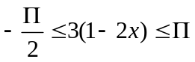
ii) |2-5x|<½

- Sketch the graph for
Y=|5-2x| hence determine domain & Range

2. (a) If a coordinate of po8nt for A is (p, p+1) and B is (P-1, 2P +1)
i) Determine the length of 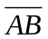
II) Midpoint

(b) If PQ divide line
AB, A(-1,2) AND B (3,4) internally in ratio of 3: 2 find the l coordinate of the
point.
3. (a) Differentiate wrt x
i) 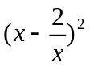 (ii) 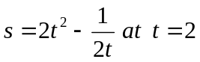
(b) proof that,
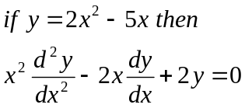
(c) i) Find the maximum value of P where P=xy=6
ii) Find the equation of norm in C (i) at x=1

4. a) Evaluate
i) 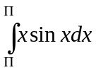
ii) 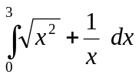
(b) Find the Area of under a curve for the curve given by 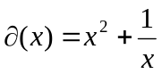 for
an interval of x=2 to x=5

5. For a Complex numbers
Z=2+3i and W=5-2i
Find a) (i) z + w (ii) 2z -w (iii) 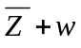.
- (i) Aurgument of Z + w.
(ii) Modulus of 2z-w

6. Given A is a matrix given
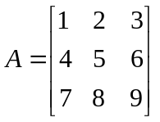
- Determine |A|
- Inverse A

7. (a) Define (i) Dot product of vector
(ii) Cross product of a vector
- Magnitude of a vector.
b) U=2I+3J
V= - 3I + 5J

Determine
(i) U.V (ii) UxV (iii) 2U+V (iv) |U+V|

- Determine a direction cosine and unit vector for 2i +3j

8. (a) Prove that
i) 2 Ө sin+sin2 Ө = Sin Ө
1 – cos 2 Ө 1- cos Ө
(ii) Sin² Ө + Cos² Ө =1

(b)Write 3 sinx +2cos x in form of
R sin (x + )

- (a) A box contains 9 orangers, 7 mangoes and 2 lemons. A fruit is drawn at random and then replaced.
Find (i) the Probability of picking and orange at first draw
(ii) Probability that the first draw and second draw the fruit picked is
an orange.
(b) A letter is picked from the name Ibrahim find the probability of picking
of tetter `i`

10. (a) Construct a truth table for the following
(i) 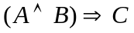
(ii) 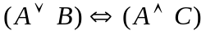
(B) Write/constract a sentence/compound statement whose logical symbols are
(i)
(ii) 